What are Closures in Python?
A closure is a function object that has access to variables in its enclosing lexical scope, even when the function is called outside that scope. A closure can “remember” the values of the variables in the enclosing scope, and use them each time it is called. The concept of closures is based on the concept of lexical scoping.
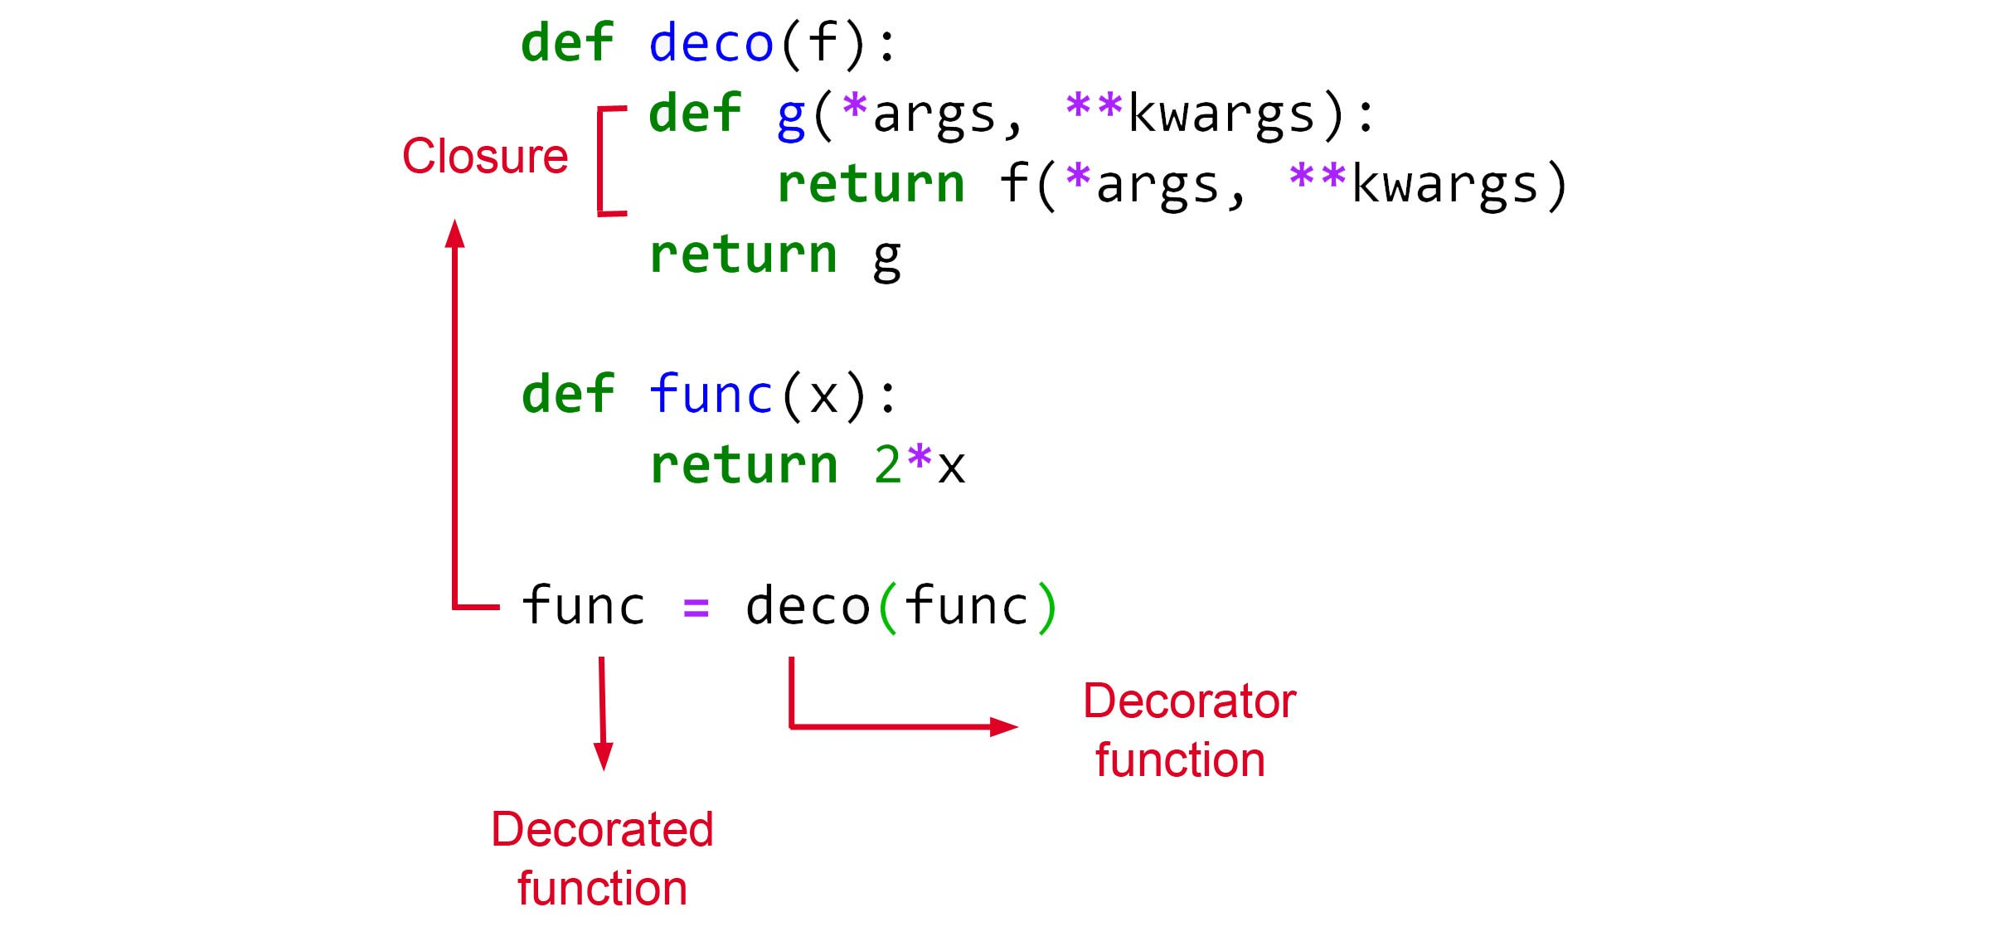
To understand closures, let’s look at an example. Consider the following code snippet:
def outer_func(x):
def inner_func(y):
return x + y
return inner_func

closure_func = outer_func(10)
print(closure_func(5)) # Output: 15
In the above example, we have defined a function outer_func that takes an argument x. Inside outer_func, we have defined another function inner_func that takes an argument y and returns the sum of x and y. Finally, outer_func returns inner_func. We then call outer_func with an argument of 10 and assign the result to closure_func. We can then call closure_func with an argument of 5 and get the output 15.
In this example, inner_func is a closure because it has access to the variable x in the enclosing scope of outer_func, even though outer_func has returned and is no longer executing. Each time we call closure_func, it “remembers” the value of x that was passed to outer_func.

How Closures in Python Work?
In Python, when a function is defined inside another function, it creates a closure. The inner function has access to the variables in the outer function’s scope.
When the outer function returns, the inner function is still able to access those variables because they are “closed over” by the closure.
In our example above, when outer_func is called with an argument of 10, it creates a closure that “closes over” the variable x with a value of 10. When inner_func is called with an argument of 5, it adds 5 to the value of x and returns the result.

